|  |  |  |
| --- | --- | --- |
| Project Settings: https://drive.google.com/open?id=1bIWSzxDlhNRyUOUX_9wq728ZlzKtD0T2mv1hEl6MYnA  Please view project settings before start | | |
| Project Check Sheet:  Please use check sheet after completing this task | | |

1. **Task Requirement / Description**
2. **UI Flow**
3. **Programming Logic**
4. **Database**

**1. Task Requirement / Description**

Customer needs a way to change the sort order for products in the admin and live site.

In the admin please sort product list by new db field sortOrder

In the admin site add a column to the product view next to options with up and down arrow so customer can move the product order

Update the clip2 site in staging url <http://staging.centralinfo.com.au/devsites/mer-wwwclip2/> so that the products are displayed in order of the new sortOrder field.

**2. UI Flow**



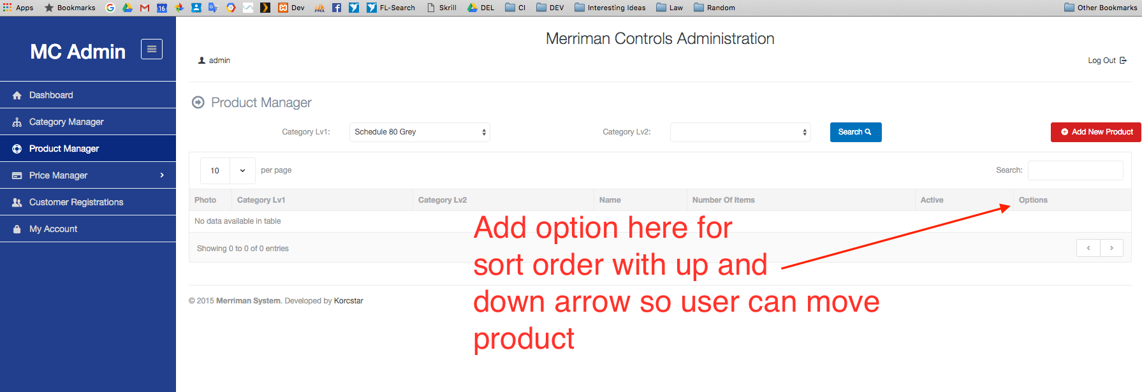

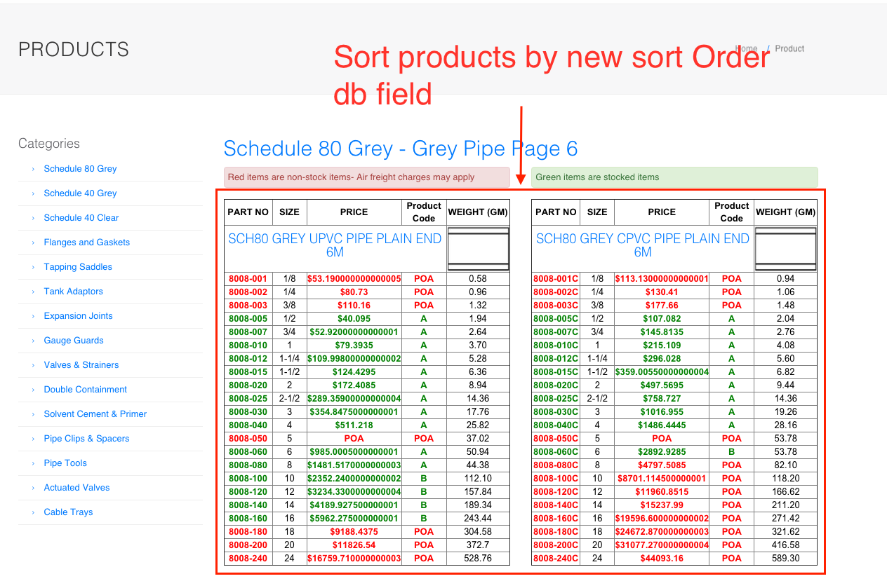

**3. Programming Logic**

* Clip2 site: Keep current logic but sort products by new sort field
* Admin: Keep current logic but sort products by sortOrder db field

**4. Database**

Add new field to products table sortOrder (int) default 0

END